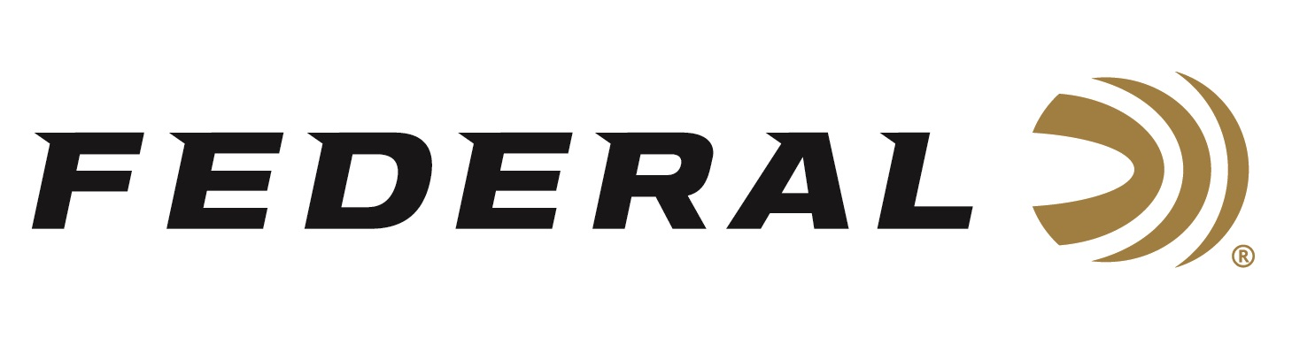

FOR IMMEDIATE RELEASE

Federal Ships Shotshell Ammunition to Help
U.S.A. Compete For Gold

ANOKA, Minnesota – May 24, 2021 – The Federal shotshells that will be used to compete with at the Olympics have begun the journey to Japan. The official ammunition of USA Shooting left the docks this week and will arrive at Camp Asaksa, Japan, site of the Olympic shooting competition. Team members Kayle Browning, Brian Burrows, Vincent Hancock, Austen Smith, and Derrick Mein will load the best shotshells Federal makes as they chase their Olympic shotgun sports dreams.

“As a company that sponsors the highest level of competition shooters, we are excited to watch them compete and to be part of their journey to bring home a medal for the U.S.A.,” stated Jason Vanderbrink, President of Federal Ammunition. “We’ve been planning for this event with USA Shooting for years. The time is finally here, and our ammo is ready to help place them on the Olympic podium.”

"The Gold Medal 24-gram International loads by Federal are incredible. They pattern so efficiently every time, and the shot size is consistent, so I never have to worry about my ammo not performing the way I need it to,” said Kayle Browning, Olympic Trap Team member. “I wouldn't trust any other load to take to the Olympics with me."

“The Federal Gold Medal Paper load is the best ammo in the world. They knew what they were doing it when they named it ‘Gold Medal’. It’s one of the highlights of my career to compete with such a quality brand of ammunition,” said Vincent Hancock. “I couldn’t be happier to be competing in the Olympics again for the fourth time in my career. I’m excited to put my talents to the test and see if I can get back onto the podium.”
“There is no greater honor than to get to represent the USA in the largest and most prestigious sporting event in the world. I have been firing a lot of Federal Gold Medal shotshells leading up to this event, which has helped me win championships. I am ready for the Olympics,” said Derrick Mein. “Federal’s consistency, quality and reliability allow me to focus on my skills and breaking targets without worry that my ammo will do the job, if I do mine.”

Federal is the official shotshell ammunition sponsor and supplier of USA Shooting, a non-profit organization that promotes the shooting sports and prepares American athletes to bring home Olympic gold. Learn more at: www.usashooting.org.
Federal Ammunition can be found at dealers nationwide or purchased online direct from Federal. For more information on all products from Federal or to shop online, visit www.federalpremium.com.

Press Release Contact: JJ Reich
Senior Manager – Press Relations
E-mail: VistaPressroom@VistaOutdoor.com

About Federal Ammunition
Federal, headquartered in Anoka, MN, is a brand of Vista Outdoor Inc., an outdoor sports and recreation company. From humble beginnings nestled among the lakes and woods of Minnesota, Federal Ammunition has evolved into one of the world's largest producers of sporting ammunition. Beginning in 1922, founding president, Charles L. Horn, paved the way for our success. Today, Federal carries on Horn's vision for quality products and service with the next generation of outdoorsmen and women. We maintain our position as experts in the science of ammunition production. Every day we manufacture products to enhance our customers' shooting experience while partnering with the conservation organizations that protect and support our outdoor heritage. We offer thousands of options in our Federal Premium and Federal® lines-it's what makes us the most complete ammunition company in the business and provides our customers with a choice no matter their pursuit.

